AHAMMED NAFIL J
251901006

PROCESS CODE INJECTION

Exp No.5

Aim:
To do process code injection on Firefox using ptrace system call. Algorithm:
- Find out the pid of the running Firefox program.
- Create the code injection file.
- Get the pid of the Firefox from the command line arguments.
- Allocate memory buffers for the shellcode.
- Attach to the victim process with PTRACE_ATTACH.
- Get the register values of the attached process.
- Use PTRACE_POKETEXT to insert the shellcode.
- Detach from the victim process using PTRACE_DETACH

Output:
[root@localhost ~]# vi codeinjection.c [root@localhost ~]# gcc codeinjection.c -o codeinject [root@localhost ~]#ps -e|grep firefox
1433 ? 00:01:23 firefox [root@localhost ~]# ./codeinject 1433
----Memory bytecode injector-----Writing EIP 0x6, process 1707

Output:

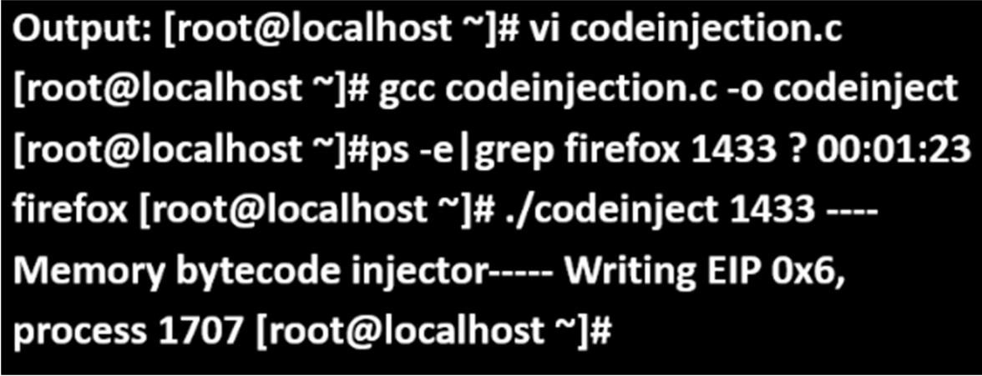

Result: Thus, the process code injection on Firefox has been successfully executed.

